***Alligator Matrix Population Model***

Two stage-based population alligator matrices were constructed by Duhman et al. (2014) to compare northern and southern populations. Alligator maturation was determined based on size. The survival rates were obtained from multiple papers, and the authors use the same rates for both populations. Juveniles and subadult stage-durations and fecundity are different between northern and southern populations.

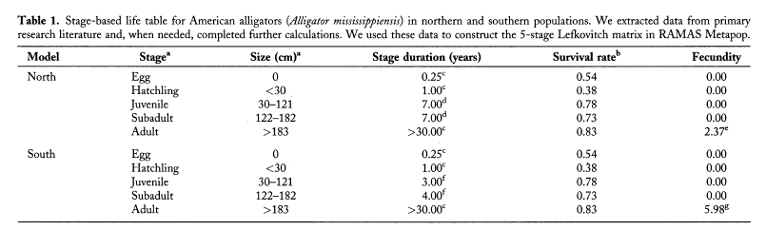

Further details about the matrix model were not provided other than the Crouse et al. (1987) method for calculating the retention rate and transition rate in a stage-based model was used. We constructed two matrices, one for each population to represent the original matrices described in the paper. The matrices constructed based on the descriptions in the paper resulted with a value in lambda of 0.87 for the northern population and 1.02 for the southern population, consistent with the values in the paper, with one modification that the duration in the subadult stage of the southern population was 3 years instead of 4 years. With this modification, both matrices also gave almost the same reproductive values and stable stage distributions listed in the paper.

|  |  |  |  |  |  |
| --- | --- | --- | --- | --- | --- |
| Original Population Matrix | | | | |  |
| 0 | 0 | 0 | 0 | F |  |
| G1 | P2 | 0 | 0 | 0 |  |
| 0 | G2 | P3 | 0 | 0 |  |
| 0 | 0 | G3 | P4 | 0 |  |
| 0 | 0 | 0 | G4 | P5 |  |

|  |  |  |
| --- | --- | --- |
| Parameters | *Northern Population* | *Southern Population* |
| F | 2.37 | 5.37 |
| G1 | 0.54 | 0.54 |
| P2 | 0 | 0 |
| G2 | 0.38 | 0.38 |
| P3 | 0.7331 | 0.5813 |
| G3 | 0.0469 | 0.1987 |
| P4 | 0.6965 | 0.5581 |
| G4 | 0.0335 | 0.1719 |
| P5 | 0.83 | 0.83 |

*Table 2. Estimated demographic parameters and calculated matrix population model elements based on Dunham et al.(2014)*

We found one major problem in the construction of the matrix. First, the model assumed a post-breeding census, but the fecundity term did not include adult or egg survival. To correct for this, we reduced the number of stages from five to four, and the fertility rate was modified to include the survival rates of the egg stage ${(S}_{e})$ over three months and adult $(S_{a}$) over 9 months $s_{e}s_{a}^{9/{12}}F$ where *F* is the product of mean clutch size, sex ratio, and percent of females breeding. The first stage was assigned to hatchlings rather than eggs.

Two models were constructed with the new fertility equation, one for each population. Then, two additional stage-structured models were constructed with the transition rates *Pi*’s and *Gi*’s incorporating the asymptotic population growth rate *λ* to discount the age distribution within a stage. In this method, *λ* was calculated iteratively as described in Caswell (2001). Additionally, a Leslie Matrix was also constructed for each population using the new fertility value.

In total, eight models were constructed with M1, M2, M3, and M4 corresponding to the Norther Population and M5, M6, M7 and M8 corresponding to the Southern Population. The table below shows the description of the model

|  |  |  |
| --- | --- | --- |
| Population | Model | Description |
| North | M1 | Original five-stage model |
| M2 | Four-stage model (hatchling, juvenile, subadult, and adult) with correction of fertility |
| M3 | Transition rates *Pi*’s and *Gi*’s were calculated incorporating λ |
| M4 | Leslie matrix |
| South | M5 | Original five-stage model |
| M6 | Four-stage model (hatchling, juvenile, subadult, and adult) with correction of fertility |
| M7 | Transition rates *Pi*’s and *Gi*’s were calculated incorporating λ |
| M8 | Leslie matrix |

Using the eight models, asymptotic population growth rate λ, stable stage distribution, reproductive value, and sensitivity and elasticity of λ to stage specific survival rate and fertility rate were calculated. Reproductive values for all models were scaled so that the reproductive value of the first stage is 1. For calculating the stable stage distribution, reproductive value, sensitivity elasticity under M4 and M8 for the juvenile and subadult stages, values for corresponding age classes were summed.



Figure 1 Asymptotic population growth rates of M1-M8



Figure 2. Stable stage distribution of Juvenile stage and adult stage for the six models.



Figure 3. Reproductive value of juveniles, subadults and adults under the six models.



Figure 4. Sensitivity of lambda to stage-specific survival and fecundity. h: hatchling, j: juvenile, s: subadults, a: adults.



Figure 5 Elasticity of lambda to stage-specific survival and fecundity. h: hatchling, j: juvenile, s: subadults, a: adults